|  |
| --- |
| **Project Analytics and Reporting** |
| To ensure projects support long-term business strategies and maximize return on investment (ROI), managers need insight into the portfolio to control the cost, quality and scheduling of project deliveries. Often, executives and managers lack a consolidated, real-time view of initiatives across an organization, preventing them from making timely, informed decisions based on accurate data. As a result, staff and financial resources are not properly allocated, resulting in decreased returns. Inefficient processes and a lack of productivity tools compound the difficulty in delivering quality projects on time and on budget due to duplicated efforts and inadequate communication. These challenges may frustrate stakeholders and constrain financial resources. |
| http://www.epmsolutions.net/assets/shared/dash_445x21.gif |
| EPM Solutions offers the Dashboards to deliver improved decision making by leveraging data from Project Server in real time. These dashboards can be tailored based on a user’s role (CIO, portfolio manager, project manager, resource manager), and they allow the user to take action through integrated collaboration capabilities. Data can be displayed in a variety of formats including, static reports, pivot tables, graphs and charts. Rolling up and consolidating data into drillable executive dashboards.  Our Project Reporting capabilities also include Earned Value, a performance measurement tool which provides better project visibility and insight into how time, cost and resources are spent and into the overall health of the projects. |
| |  |  | | --- | --- | | http://www.epmsolutions.net/assets/shared/bullet.gif | Role Based SharePoint Dashboards | | http://www.epmsolutions.net/assets/shared/bullet.gif | Role Based SQL Reports Dashboards | | http://www.epmsolutions.net/assets/shared/bullet.gif | Executive Score Card | |
| **Role Based Dashboards** *Dashboard view for executives and managers offers high level key project health.*  EPMS Executive Dashboards and Scorecards provide executives easy access to web-based, real time, project data that displays key business metrics.  Dashboards are available for Portfolio Managers, Project Mangers, Resource Managers, Financial Managers and top level Executives. Aggregated project related data is also summarized with MS Business Scorecards allowing drill down into charts, tables and visual metaphors with Visio and MapPoint.  http://www.epmsolutions.net/assets/services/SharePoint.gif *Sample: Role Based Dashboards (SharePoint)*  http://www.epmsolutions.net/assets/services/SQLt.gif *Sample: Role Based Dashboards (SQLt)*  http://www.epmsolutions.net/assets/services/Dashboard.gif *Sample: Executive Score Card Dashboard* |
| |  |  | | --- | --- | | http://www.epmsolutions.net/assets/shared/bullet.gif | **Gain Project Intelligence with Project Portfolio Dashboard**  A Project Portfolio Dashboard consolidates project information from multiple data sources, aligns IT spending with business strategy. This solution includes components such as digital dashboard for executives to track real- time information on key performance indicators (KPI) and business scorecard to help executives evaluate the project performance. The integrated view of all key projects (or grouping of projects), allows users to make faster, better-informed decisions.  Project Portfolio Dashboard is for CIO, CEO and PMO to gain insight into the same data, to identify serious problems before it is too late. It enables them to investigate causes for poor performance and to increase the success of their critical projects. | | http://www.epmsolutions.net/assets/shared/bullet.gif | **Unleash the power of collaborative workforce planning Using Resource Management Dashboard**  Optimize resources and increase utilization, across your entire organization. Our OLAP-based analytics helps management understand resource availability, allocations, forecasts, operational variances, and human capital utilization across the organization, at granular levels such as by business unit, workgroup, or resource type and more. | | http://www.epmsolutions.net/assets/shared/bullet.gif | **Gather insight into a project Using Project Management Dashboard**  PMO Directors, senior project managers and business executives have the need for cross-project, top-down project reports, and the tool that automates the project reporting process. EPM Solutions developed a series of role based dashboards that aggregates disparate data across multiple projects which help them identify key project issues and  forecast resource utilization. | |
| **Custom Views and Reporting**  Unlocking the ability to gather insight into projects is extremely valuable. Using Microsoft SQL Reporting Service and the power of EPMS Report Manager, EPM Solutions can produce better, more robust reports than ever before. EPM customers now address both basic and highly sophisticated, multi-dimensional reports which contribute to their overall efficiency, accuracy and quality of their project and portfolio of projects.  **Project Life Cycle Gated Dashboard**  EPMS Project Life Cycle Gated Dashboard provides gated phases implementing templated artifacts & documents; it is designed to provide an end-to-end solution for taking documented project managements best practices and integrate them into a tool set.  Integrated into Project Server & SharePoint you can quickly adopt Project Life Cycles that meet the needs of the project size and department application. You can use our standard project and product life cycle models, Microsoft Solutions Framework, PMI PMBOK or have your own configured.  Theses dashboards provided gated phases implementing templated artifacts and documents including: Portfolio Committee Charter Process, Project Ranking Criteria, Selection Process, Project Inventory Process, Portfolio Project Initiation, Portfolio Reporting Processes, Portfolio Reviews Process, Portfolio Budget Management Process, Portfolio Financial Analysis, Portfolio Document Management Process, Portfolio Risk Management Process, Portfolio Issue Management Process, Portfolio Scope Change Control, Process, Portfolio Project Reporting Process, Portfolio Quality Process, Portfolio Communication Process, and Portfolio Project Closure Review. |

**Project Analytics for Project Management**

Posted on Mon 31 Aug 2009, 5:09 am, by Patrick Lavey, under [Services](http://www.projectp.com/weblog/category/services/).

The information below provides an overview of the reporting and metrics available in Project Analytics for Project Management. The synopses can be found on the Dashboard Index and describe each tab within the Project Management Application. Additional details on each of the screenshots describe details of the metrics and functionality within each of the interactive dashboard pages.

**Project Management**

Screenshots of the default dashboard for each tab within the Project Management application area are shown below. Results in the dashboards can be filtered using the parameters at the top of each dashboard. Additional query modifications are available using the ‘Modify’ link.

**1.1 – Project Performance**

Provides the default-aggregated view of information for all the projects satisfying the dashboard filter criteria, with the ability to drill down to a specific project details. This dashboard page provides quick overview of key performance indicators such as ITD margin %, ITD cost and revenue variances for the group of projects or a specific project. It also provides a quick snapshot of covering cost, efforts, revenue, billability and billing for the group of projects or for a specific project.

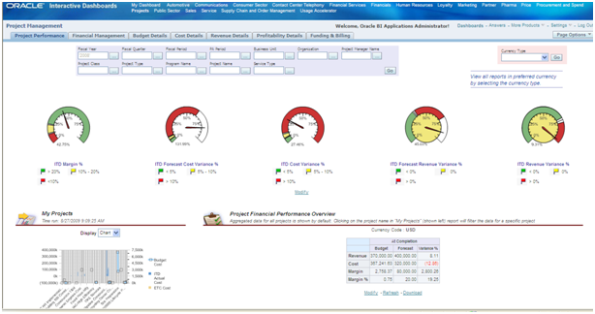

Gauges show margins, variance for costs, revenue and forecasts. My Projects displays in chart or table format Budget, Actual and ETC costs for the user’s projects. Financial Performance aggregates the data in My Projects. Clicking on a specific project filters all Project Performance data for that specific project    .

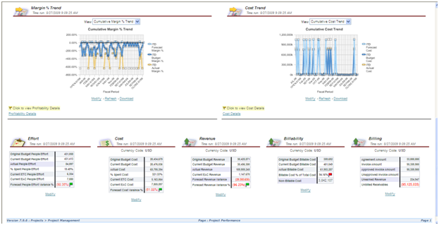

Margin Percentage Trend displays ITD Forecast, Budget, and Cost Margins over time and allows drill thru to Profitability Details. Cumulative Cost Trend shows ITD Forecast, Budget, and Cost Totals over time and allows drill thru to Cost Details.

Effort, Cost, Revenue, Billability and Billing compare Original Budget, Current Budget, Actuals, Percent Spent, ETC, EAC, and calculate Variances using those factors.

**1.2 – Financial Management**

Provides the default-aggregated view of information covering the financial aspects for a group of projects or a specific project satisfying the dashboard filter criteria. This dashboard page provides quick overview of Inception-to-date performance, variances, cumulative revenue, cost, margin, billing and period over period changes and the funding summary with the ability to drill down to takes or resources, including trending.

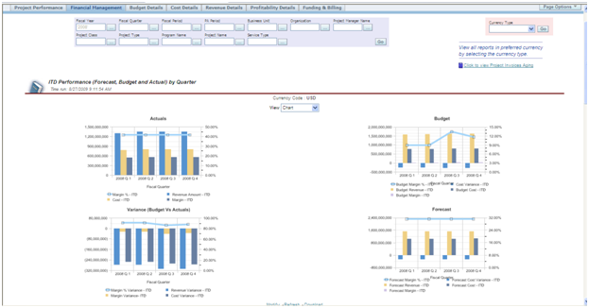

Actuals, Budget, Variance (Budget vs. Actuals), Forecast display Cost and Revenue Actuals, Budget and Forecast Amounts, Margins, Variance all by Fiscal Quarter. If Financials Analytics is enabled, you can drill thru to Procurement and Spend Analytics.

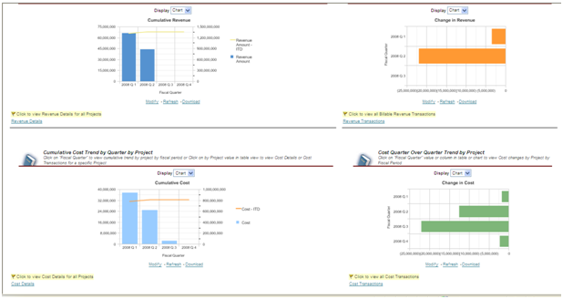

Trend views show Revenue and Cost Trends by Quarter. Further, Revenue and Costs display Quarter over Quarter Trends. Drill thru to Cost and Revenue Details and Cost and Revenue Transactions is possible from these charts (more trends follow below).

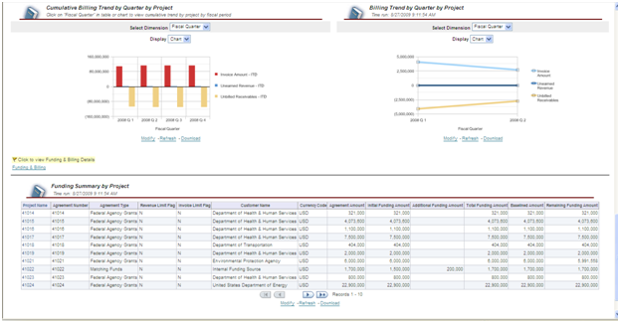

Trends: Invoice Amount, Unearned Revenue and Unbilled Receivables are displayed by Quarter by Project. Funding Summary by Project shows Original Funding, Additional Funding, Total Funding, Baselined, and Remaining Funding.

**1.3 – Budget Details**

Provides the detailed budget information for the projects and the tasks under the projects with the ability to drill down to child tasks and resources. It provides the budget accuracies for cost and revenue, budget changes in comparison with original budgets, including trending and other details.

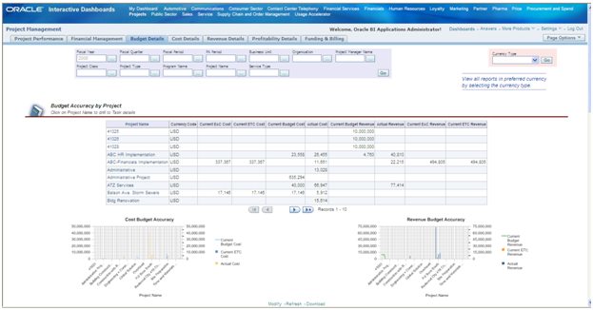

Budget Accuracy by Project displays EAC, ETC, Current Budget, Actual Costs, and Actual Revenue amounts. Clicking on Project allows task drilldown. Amounts are charted by Cost Budget and Revenue Budget Accuracy. You can also drill thru to Budget Accuracy by Financial Resource.

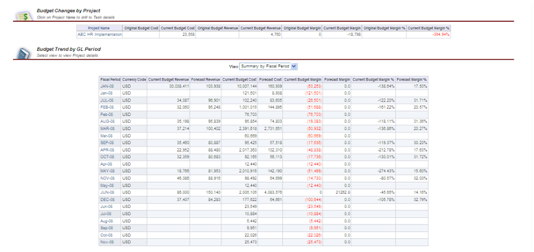

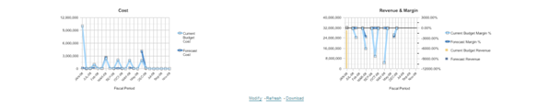

Budget Trend by GL Period displays Current Cost and Revenue Budgets, Forecasts, Budget Margin and Forecast Margins. Amounts are charted below the table. You can drill thru to Cumulative Budget Trend by GL Period and to Budget Transactions.

**1.4 – Cost Details**

Provides the detailed cost information for the projects and the tasks under the projects with the ability to drill down to child tasks and resources. It provides the cost comparisons of employees, job codes, tasks and other resources, including trending and other details.

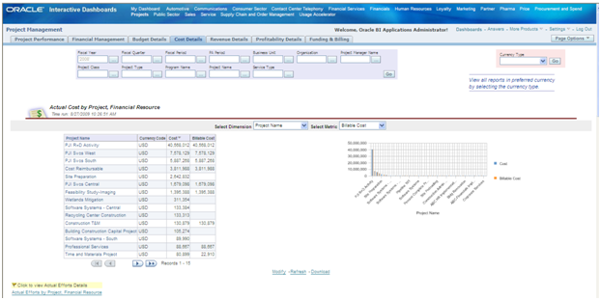

Actual Cost by Project, Financial Resource shows total Costs and Billable Costs by project. These amounts are charted as well. You can drill thru to Actual Efforts by Project, Financial Resource.

Dimensions include Project Name (shown), Expenditure Category, Resource Type, Top Level Task Name and Supplier Name. Metric includes Billable Cost, Non-billable Cost, Capitalizable Cost.

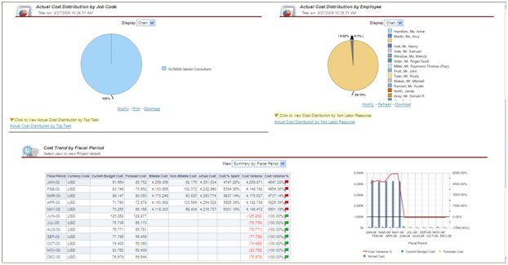

Actual Cost Distribution by Job Code can be displayed in a Chart of a Table. This is also true for Actual Cost Distribution by Employee (named Person).

Cost Trend by Fiscal Period displays Current, Forecast, Billable, Non-billable, Actual Costs, along with Cost Variance and Cost Variance Percentage. Amounts are charted as well.

Drill thru is possible to Cumulative Cost by Fiscal Period, Cumulative Cost Billability by Project, Cumulative Cost Variance by Project, People Effort by GL Period, and Cost Transactions.

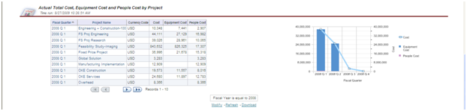

Actual Total Cost, Equipment Cost, and People Cost by Project breaks these cost amounts out by project. Amounts are charted as well.

**1.5 – Revenue Details**

Provides the detailed revenue information for the projects and the tasks under the projects with the ability to drill down to child tasks and resources. It provides the revenue comparisons of employees, job codes, tasks and other resources, including trending and other details.

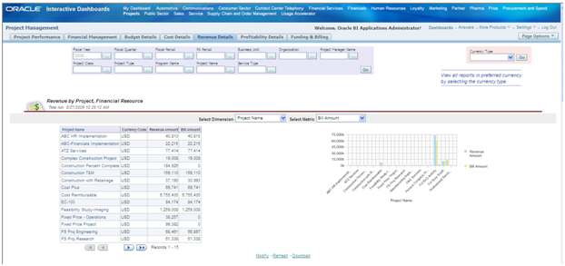

Revenue by Project, Financial Resource displays Revenue and Bill amounts by project. Amounts are also charted.

Dimensions include Project Name, Resource Type, Top Task Level Name, Revenue Category and Customer.

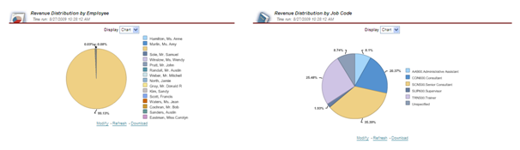

Revenue Distribution by Employee charts each Employee’s percentage of revenue. Revenue Distribution by Job Code charts revenue contribution by Job Code.

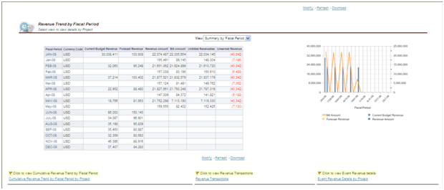  
Revenue Trend by Fiscal Period displays Current Budget Revenue, Forecast Revenue, Revenue Amounts, Bill Amounts, Unbilled Receivables, and Unearned Revenue by Project. Some of these are charted as well.

You can drill thru to Cumulative Revenue Trend by Fiscal Period, Revenue Transactions and Event Revenue Details by Project.

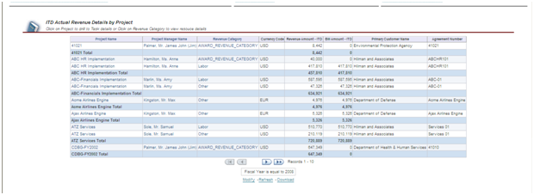

ITD Actual Revenue Details by Project shows Revenue and Bill Amounts by Project, Project Manager, Revenue Category, Primary Customer, and Agreement Number

**1.6- Profitability Details**

Provides the detailed profitability information for the projects and tasks under the projects with the ability to drill down to child tasks and resources. It provides the comparisons of the profitability to the budgets and forecasts, and period over period changes in the margin, including trending and other details.

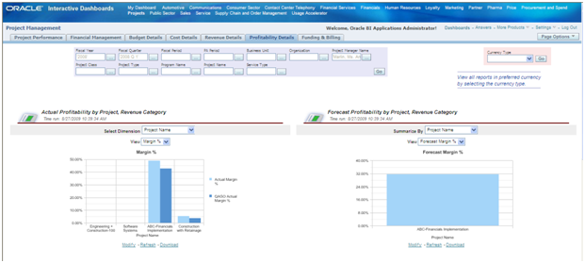

Actual Profitability by Project, Revenue Category displays Actual Margin compared to QAGO Actual Margin by project. Forecast Margin displays Forecast by project.

Dimension includes Project Name, Expenditure Category, Revenue Category, Job Name. View includes Margin Percentage, Margin, Revenue Cost and Data.

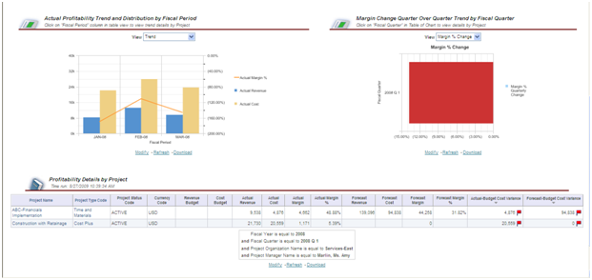

Actual Profitability Trend and Distribution by Fiscal Period shows Actual Margin Percentage, Actual Revenue and Actual Costs. View includes Trend, Revenue Distribution, Cost Distribution, Margin Distribution and Data.

Profitability Details by Project displays Revenue and Cost Budget, Actual Cost, Actual Revenue, Actual Margin, Actual Margin Percentage, Forecast Revenue, Forecast Cost, Forecast Margin, Forecast Margin Percentage, Actual/Budget Cost Variance, and Forecast/Budget Cost Variance by Project.

**1.7- Funding & Billing**

Provides the funding and billing details for a project or a group of projects and the tasks under the projects. It provides the overview of agreement amount, funding amount that is assigned to a project, revenue amount that is accrued, invoice amount that is billed, funding changes and the remaining funding that alerts the organizations the potential capacity or efficiency problem.

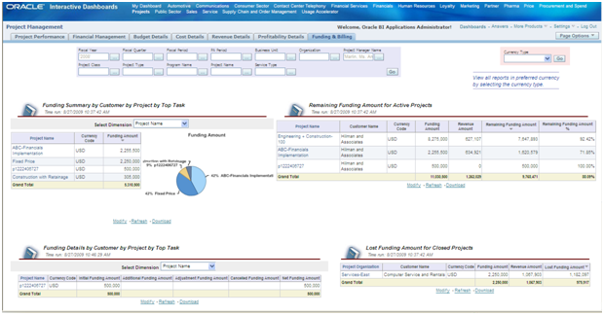

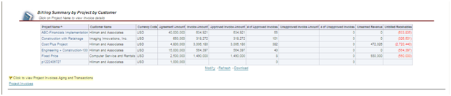

Funding Summary by Customer by Project by Top Task shows Funding Amounts by the following Dimensions: Project Name, Top Task, and Customer Name. Amounts can be graphically displayed as well.

Remaining Funding Amount for Active Projects displays Funding Amount, Revenue Amount, Remaining Funding Amount, and Remaining Funding Amount Percentage.

Funding Details by Customer by Project by Top Task shows Initial Funding, Additional Funding, Adjustment Funding, Cancelled Funding and Net Funding by the following Dimensions: Project Name, Top Task, and Customer Name.

Lost Funding for Closed Projects shows Funding Amount, Revenue Amount and Lost Funding for closed projects. Includes Project Organization.

Billing Summary by Project by Customer shows Agreement Amount, Invoice Amount, Approved Invoice Amount, Number of Approved Invoices, Unapproved Invoices Amount, Number of Unapproved Invoices, Unearned Revenue and Unbilled Receivables by Project and Customer.

**Hidden Dashboard Pages**

By default, the hidden Dashboard Pages do not display within their application area. They can be added to the application area. The hidden pages below contain Transaction Details

**1.8- Cost Transactions**

Provides detailed cost transactions at expenditure date and item level for a given project, and resource. This dashboard is designed to provide weekly or daily cost transactions report.

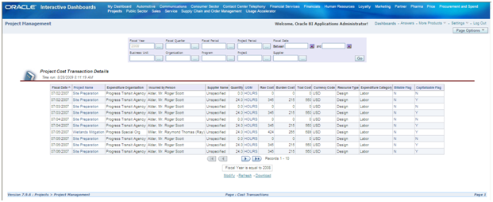

Project Cost Transaction Details displays cost data by Fiscal Date, Project Name, Expenditure Organization, Incurred by Person, Supplier Name, Quantity, UOM, Raw Cost, Burden Cost, Total Cost, Currency, Resource Type, Expenditure Category, Billable Flag, and Capitalizable Flag. All Data may be displayed or can be sorted. Filters can be used to refine the data displayed. Data can be downloaded to Excel.

**1.9- Revenue Transactions**

Provides detailed revenue transactions at expenditure date and item level for a given project, and resource. This dashboard is designed to provide weekly or daily revenue transactions report.

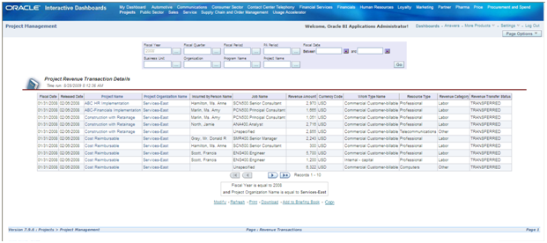

Project Revenue Transaction Details displays data by Fiscal Date, Project Name, Project Organization, Incurred by Person, Job Name, Revenue Amount, Currency, Work Type, Resource Type, Revenue Category and Revenue Transfer Status. All Data may be displayed or can be sorted. Filters can be used to refine the data displayed. Data may be downloaded to Excel, or saved off to a ‘Briefing Book’, which either statically or in updatable format.

**1.9a – Budget Transactions**

Provides detailed budget transactions at budget type, version and budget period level .  
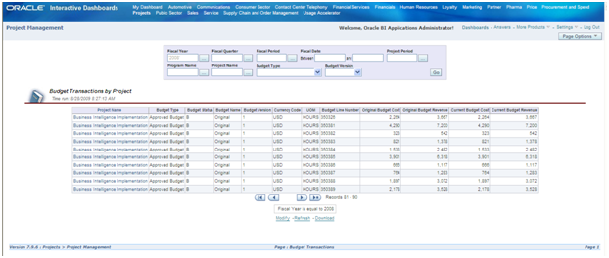

Budget Transactions by Project display data by Project Name, Budget Type, Budget Status, Budget Name, Budget Version, Currency, UOM, Budget Line, Original Budget Cost, Original Budget Revenue, Current Budget Cost, and Current Budget Revenue. All Data may be displayed or can be sorted. Filters can be used to refine the data displayed. Data may be downloaded to Excel.

**Summary**

The information above should provide the reader with sufficient information on the Project Management application area within Project Analytics to know about the breadth of the reporting capabilities for that part of Project Analytics.

Next Up: Please return soon for the next Project Analytics summary blog, this time for Project Executives.

Mon 31 Aug 2009

[**Project Analytics for Project Management**](http://www.projectp.com/weblog/2009/08/31/project-analytics-for-project-management/)

Posted by Patrick Lavey, under [Services](http://www.projectp.com/weblog/category/services/). Tags: [oracle project analytics](http://www.projectp.com/weblog/tag/oracle-project-analytics/), [oracle project billing](http://www.projectp.com/weblog/tag/oracle-project-billing/), [Oracle project costing](http://www.projectp.com/weblog/tag/oracle-project-costing/), [Oracle Project Management](http://www.projectp.com/weblog/tag/oracle-project-management/)  
  
[No Comments »](http://www.projectp.com/weblog/2009/08/31/project-analytics-for-project-management/#respond)

The information below provides an overview of the reporting and metrics available in Project Analytics for Project Management. The synopses can be found on the Dashboard Index and describe each tab within the Project Management Application. Additional details on each of the screenshots describe details of the metrics and functionality within each of the interactive dashboard pages.

**Project Management**

Screenshots of the default dashboard for each tab within the Project Management application area are shown below. Results in the dashboards can be filtered using the parameters at the top of each dashboard. Additional query modifications are available using the ‘Modify’ link.

**1.1 – Project Performance**

Provides the default-aggregated view of information for all the projects satisfying the dashboard filter criteria, with the ability to drill down to a specific project details. This dashboard page provides quick overview of key performance indicators such as ITD margin %, ITD cost and revenue variances for the group of projects or a specific project. It also provides a quick snapshot of covering cost, efforts, revenue, billability and billing for the group of projects or for a specific project.



Gauges show margins, variance for costs, revenue and forecasts. My Projects displays in chart or table format Budget, Actual and ETC costs for the user’s projects. Financial Performance aggregates the data in My Projects. Clicking on a specific project filters all Project Performance data for that specific project    .



Margin Percentage Trend displays ITD Forecast, Budget, and Cost Margins over time and allows drill thru to Profitability Details. Cumulative Cost Trend shows ITD Forecast, Budget, and Cost Totals over time and allows drill thru to Cost Details.

Effort, Cost, Revenue, Billability and Billing compare Original Budget, Current Budget, Actuals, Percent Spent, ETC, EAC, and calculate Variances using those factors.

**1.2 – Financial Management**

Provides the default-aggregated view of information covering the financial aspects for a group of projects or a specific project satisfying the dashboard filter criteria. This dashboard page provides quick overview of Inception-to-date performance, variances, cumulative revenue, cost, margin, billing and period over period changes and the funding summary with the ability to drill down to takes or resources, including trending.



Actuals, Budget, Variance (Budget vs. Actuals), Forecast display Cost and Revenue Actuals, Budget and Forecast Amounts, Margins, Variance all by Fiscal Quarter. If Financials Analytics is enabled, you can drill thru to Procurement and Spend Analytics.



Trend views show Revenue and Cost Trends by Quarter. Further, Revenue and Costs display Quarter over Quarter Trends. Drill thru to Cost and Revenue Details and Cost and Revenue Transactions is possible from these charts (more trends follow below).



Trends: Invoice Amount, Unearned Revenue and Unbilled Receivables are displayed by Quarter by Project. Funding Summary by Project shows Original Funding, Additional Funding, Total Funding, Baselined, and Remaining Funding.

**1.3 – Budget Details**

Provides the detailed budget information for the projects and the tasks under the projects with the ability to drill down to child tasks and resources. It provides the budget accuracies for cost and revenue, budget changes in comparison with original budgets, including trending and other details.



Budget Accuracy by Project displays EAC, ETC, Current Budget, Actual Costs, and Actual Revenue amounts. Clicking on Project allows task drilldown. Amounts are charted by Cost Budget and Revenue Budget Accuracy. You can also drill thru to Budget Accuracy by Financial Resource.





Budget Trend by GL Period displays Current Cost and Revenue Budgets, Forecasts, Budget Margin and Forecast Margins. Amounts are charted below the table. You can drill thru to Cumulative Budget Trend by GL Period and to Budget Transactions.

**1.4 – Cost Details**

Provides the detailed cost information for the projects and the tasks under the projects with the ability to drill down to child tasks and resources. It provides the cost comparisons of employees, job codes, tasks and other resources, including trending and other details.



Actual Cost by Project, Financial Resource shows total Costs and Billable Costs by project. These amounts are charted as well. You can drill thru to Actual Efforts by Project, Financial Resource.

Dimensions include Project Name (shown), Expenditure Category, Resource Type, Top Level Task Name and Supplier Name. Metric includes Billable Cost, Non-billable Cost, Capitalizable Cost.



Actual Cost Distribution by Job Code can be displayed in a Chart of a Table. This is also true for Actual Cost Distribution by Employee (named Person).

Cost Trend by Fiscal Period displays Current, Forecast, Billable, Non-billable, Actual Costs, along with Cost Variance and Cost Variance Percentage. Amounts are charted as well.

Drill thru is possible to Cumulative Cost by Fiscal Period, Cumulative Cost Billability by Project, Cumulative Cost Variance by Project, People Effort by GL Period, and Cost Transactions.



Actual Total Cost, Equipment Cost, and People Cost by Project breaks these cost amounts out by project. Amounts are charted as well.

**1.5 – Revenue Details**

Provides the detailed revenue information for the projects and the tasks under the projects with the ability to drill down to child tasks and resources. It provides the revenue comparisons of employees, job codes, tasks and other resources, including trending and other details.



Revenue by Project, Financial Resource displays Revenue and Bill amounts by project. Amounts are also charted.

Dimensions include Project Name, Resource Type, Top Task Level Name, Revenue Category and Customer.



Revenue Distribution by Employee charts each Employee’s percentage of revenue. Revenue Distribution by Job Code charts revenue contribution by Job Code.

  
Revenue Trend by Fiscal Period displays Current Budget Revenue, Forecast Revenue, Revenue Amounts, Bill Amounts, Unbilled Receivables, and Unearned Revenue by Project. Some of these are charted as well.

You can drill thru to Cumulative Revenue Trend by Fiscal Period, Revenue Transactions and Event Revenue Details by Project.



ITD Actual Revenue Details by Project shows Revenue and Bill Amounts by Project, Project Manager, Revenue Category, Primary Customer, and Agreement Number

**1.6- Profitability Details**

Provides the detailed profitability information for the projects and tasks under the projects with the ability to drill down to child tasks and resources. It provides the comparisons of the profitability to the budgets and forecasts, and period over period changes in the margin, including trending and other details.



Actual Profitability by Project, Revenue Category displays Actual Margin compared to QAGO Actual Margin by project. Forecast Margin displays Forecast by project.

Dimension includes Project Name, Expenditure Category, Revenue Category, Job Name. View includes Margin Percentage, Margin, Revenue Cost and Data.



Actual Profitability Trend and Distribution by Fiscal Period shows Actual Margin Percentage, Actual Revenue and Actual Costs. View includes Trend, Revenue Distribution, Cost Distribution, Margin Distribution and Data.

Profitability Details by Project displays Revenue and Cost Budget, Actual Cost, Actual Revenue, Actual Margin, Actual Margin Percentage, Forecast Revenue, Forecast Cost, Forecast Margin, Forecast Margin Percentage, Actual/Budget Cost Variance, and Forecast/Budget Cost Variance by Project.

**1.7- Funding & Billing**

Provides the funding and billing details for a project or a group of projects and the tasks under the projects. It provides the overview of agreement amount, funding amount that is assigned to a project, revenue amount that is accrued, invoice amount that is billed, funding changes and the remaining funding that alerts the organizations the potential capacity or efficiency problem.





Funding Summary by Customer by Project by Top Task shows Funding Amounts by the following Dimensions: Project Name, Top Task, and Customer Name. Amounts can be graphically displayed as well.

Remaining Funding Amount for Active Projects displays Funding Amount, Revenue Amount, Remaining Funding Amount, and Remaining Funding Amount Percentage.

Funding Details by Customer by Project by Top Task shows Initial Funding, Additional Funding, Adjustment Funding, Cancelled Funding and Net Funding by the following Dimensions: Project Name, Top Task, and Customer Name.

Lost Funding for Closed Projects shows Funding Amount, Revenue Amount and Lost Funding for closed projects. Includes Project Organization.

Billing Summary by Project by Customer shows Agreement Amount, Invoice Amount, Approved Invoice Amount, Number of Approved Invoices, Unapproved Invoices Amount, Number of Unapproved Invoices, Unearned Revenue and Unbilled Receivables by Project and Customer.

**Hidden Dashboard Pages**

By default, the hidden Dashboard Pages do not display within their application area. They can be added to the application area. The hidden pages below contain Transaction Details

**1.8- Cost Transactions**

Provides detailed cost transactions at expenditure date and item level for a given project, and resource. This dashboard is designed to provide weekly or daily cost transactions report.



Project Cost Transaction Details displays cost data by Fiscal Date, Project Name, Expenditure Organization, Incurred by Person, Supplier Name, Quantity, UOM, Raw Cost, Burden Cost, Total Cost, Currency, Resource Type, Expenditure Category, Billable Flag, and Capitalizable Flag. All Data may be displayed or can be sorted. Filters can be used to refine the data displayed. Data can be downloaded to Excel.

**1.9- Revenue Transactions**

Provides detailed revenue transactions at expenditure date and item level for a given project, and resource. This dashboard is designed to provide weekly or daily revenue transactions report.



Project Revenue Transaction Details displays data by Fiscal Date, Project Name, Project Organization, Incurred by Person, Job Name, Revenue Amount, Currency, Work Type, Resource Type, Revenue Category and Revenue Transfer Status. All Data may be displayed or can be sorted. Filters can be used to refine the data displayed. Data may be downloaded to Excel, or saved off to a ‘Briefing Book’, which either statically or in updatable format.

**1.9a – Budget Transactions**

Provides detailed budget transactions at budget type, version and budget period level .  


Budget Transactions by Project display data by Project Name, Budget Type, Budget Status, Budget Name, Budget Version, Currency, UOM, Budget Line, Original Budget Cost, Original Budget Revenue, Current Budget Cost, and Current Budget Revenue. All Data may be displayed or can be sorted. Filters can be used to refine the data displayed. Data may be downloaded to Excel.

**Summary**

The information above should provide the reader with sufficient information on the Project Management application area within Project Analytics to know about the breadth of the reporting capabilities for that part of Project Analytics.

Next Up: Please return soon for the next Project Analytics summary blog, this time for Project Executives.

## [Wrong From the Start](http://www.projectp.com/weblog/2009/09/08/wrong-from-the-start/)

Posted by Glenn Meyer, under [Industries Corner](http://www.projectp.com/weblog/category/industry-corner/). Tags: [earned value](http://www.projectp.com/weblog/tag/earned-value/), [estimate at completion](http://www.projectp.com/weblog/tag/estimate-at-completion/), [estimate to complete](http://www.projectp.com/weblog/tag/estimate-to-complete/), [Glenn Meyer](http://www.projectp.com/weblog/tag/glenn-meyer/), [Oracle Project Management](http://www.projectp.com/weblog/tag/oracle-project-management/), [PMP](http://www.projectp.com/weblog/tag/pmp/), [Project Portfolio Mgmt](http://www.projectp.com/weblog/tag/project-portfolio-mgmt/)  
  
[No Comments »](http://www.projectp.com/weblog/2009/09/08/wrong-from-the-start/#respond)

When projects go wrong, they generally go wrong at the beginning. As my experience is largely in the defense industry, most of the following is derived from those experiences. Poorly defined requirements lead to poorly defined statements of work and specifications which lead to unrealistic expectations both at the customer and at the supplier. This fundamental communications issue blights projects and affects them throughout their life cycle. Why do project teams make these same mistakes over and over and over? After scores of interviews and post-mortems in the last twenty years, it unsurprisingly comes down to poor practices and lack of discipline. Is this the project team’s fault? Only partly. Often it is the customer’s fault, particularly in the world of government contracts. That the US Government attempts to employ good project management practice is a given; however their shortcomings are three-fold.

First, the program managers may be on promotion track, and that means reluctance to admit to problems.

Second, the program controls / Earned Value organization seems often more interested in accounting than in project management.

Third, the persons developing the statements of work and technical requirements fail to make them both clear and realistic.

Let’s start with the last first, as that is where a project can be at risk from inception. The problem with statements of work for major development procurements is that the persons writing them often either do not know how to define the requirements, when the aim is inventing technology, or they may have a jaundiced view of requirements definition, i.e. they want to leave certain things “obscure” in order to maintain a degree of “flexibility” in the future or they want to “challenge” the supplier to create a “better” solution. The former circumstance is merely a fact of life, but the later creates misunderstandings leading to unnecessary changes, do-overs, delays, and increased cost without advancing the project toward the ultimate goal of providing what the end-user needs. Over the last twenty years I worked with several engineering managers who avoided stating firm requirements because of the mistaken ideas that firm requirements tied their hands or reduced “creativity”. This then is a warning sign for the risk identification process…ill-defined requirements mean greater exposure to both buyer and seller.

So how does the “seller” correct this when it means telling the customer the he isn’t really doing a good job? The IT services model of defining requirements through joint analysis and jointly agreeing on requirements is a good one, as is employing the intent of the spiral project life cycle model which allows the risky bits to be identified and resolved at the lowest possible cost. If the risks cannot be reduced, then the project requirements and objectives can be modified or, if the costs begin to exceed the benefits, then the project may be abandoned entirely. This again will require a close relationship with the customer and may be a difficult sell on the supplier’s part. It certainly is worth approaching when you find yourself in the vague statement of work circumstance. One successful technique is to put that reluctant technical manager in the seller’s situation by asking him if he would sign a firm, fixed price contract as a home builder based only on an artist’s sketch of the house. You can infer what to do with the analogy from there. Ideally, we would want that technical manager to hire us to design the house in addition to building it. However, he still must provide basic requirements for us, for him, and for the project to be successful.

Establishing plain, straightforward, and honest communications is the only method for dealing with the first circumstance, that of a customer project or program manager who, for whatever reason, doesn’t want to hear about problems, issues, and risks. This, for the seller, may be a no-win situation, but it is better to have warned the customer’s project manager and to have told him the truth rather than being complicit in a disaster. A manager friend of mine had a sign on his desk “Come to me early with a problem, and you have a partner in finding a solution. Come to me late with a disaster, and you have a judge.” I employed that thought literally when I sat the customer project manager chair. That was one of the first discussions I would have with the seller on a newly contracted development project. It may be painful, but it works, and the pain is short term, rather than a reputation destroyer.

Using earned value as a project management technique is essential. That the Government’s EV people come from a financial background may present a challenge when attempting to design, organize, and build a project that results in meaningful measurements and statistics. I found three things crucial in earned value management: objective measurements, a deliverable/product breakdown structure as opposed to a “product-oriented” WBS (this often required deviation from the government’s contract WBS or MIL-HDBK-881A), and using labor hours for EV measurements on labor efforts. I’ll discuss each of these in a subsequent blog.

Wed 2 Sep 2009

[**Project Analytics for Project Executives**](http://www.projectp.com/weblog/2009/09/02/project-analytics-for-project-executives/)

Posted by Patrick Lavey, under [Services](http://www.projectp.com/weblog/category/services/). Tags: [earned value](http://www.projectp.com/weblog/tag/earned-value/), [oracle project analytics](http://www.projectp.com/weblog/tag/oracle-project-analytics/), [oracle project billing](http://www.projectp.com/weblog/tag/oracle-project-billing/), [Oracle project costing](http://www.projectp.com/weblog/tag/oracle-project-costing/), [Oracle Project Management](http://www.projectp.com/weblog/tag/oracle-project-management/), [Project Portfolio Mgmt](http://www.projectp.com/weblog/tag/project-portfolio-mgmt/)  
  
[No Comments »](http://www.projectp.com/weblog/2009/09/02/project-analytics-for-project-executives/#respond)

The information below provides an overview of the reporting and metrics available in Project Analytics for Project Executives. The pages have been configured to use Quarters; however, Period could have been configured as the ‘time grain’ instead. The information on each tab in the Project Executive area has been taken from the Dashboard Index. Additional information below each of the screenshots describe details of the metrics and functionality within each of the interactive dashboard pages.

**Project Executive**

Screenshots of the default dashboard for each tab within the Project Management reporting area are shown below. Results in the dashboards can be filtered using the parameters at the top of each dashboard (Fiscal Year, Fiscal Quarter, Fiscal Period, PA Period, Business Unit, Organization, Project Manager Name, Project Class, Project Type, Program Name, Project Name, and Service Type). Additional query modifications are available using the ‘Modify’ link.

**2.1 – Overview**

Provides the default aggregated view of information for all the organizations satisfying the dashboard filter criteria, with the ability to drill down to project details that each organization responsible for. This dashboard page provides quick overview of Inception-to-date performance, variances, and the number of projects that each organization is currently executing and their profitability and cost performance.

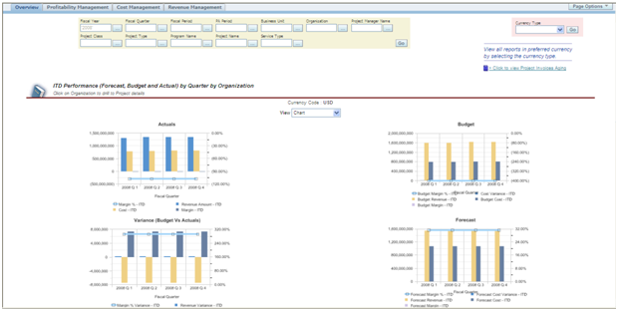

ITD Performance (Forecast, Budget and Actual) by Quarter and Organization uses Views (Chart, ITD Data, and ITD Variance) to display the information. You can drill thru to Project Invoice Aging as well as to Project Commitments. The graphs include ITD Margin %, Cost, Revenue Margin, Forecast Cost, Forecast Revenue, Forecast Margin and Forecast Variance.

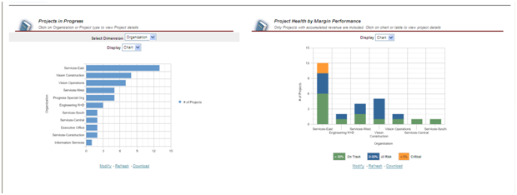

Projects in Progress uses Dimensions (Organization and Project Type) to Display (Chart or Table) the number of ongoing projects. Changing the Dimension changes the display for the charts adjacent and those listed immediately below. Project Health by Margin Performance Displays (Chart or Table) the health of the projects with accumulated revenue (On Track, At Risk, Critical).

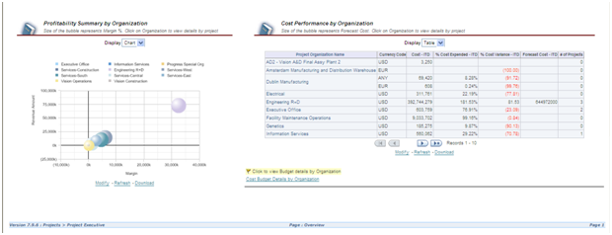

Profitability Summary by Organization Displays (Chart or Table) the margin percentages of the projects. Revenue Amounts and Margin Amounts represent the axes of the graph. Cost Performance by Organization Displays (Chart or Table) Percentage Cost Variance by the Dimension selected. You can drill thru to Cost Budget Details by Organization.

**2.2 – Profitability Management**

Provides the detailed profitability information for the organizations and the projects under the organizations with the ability to drill down to projects, tasks and resources. It provides the comparisons of the profitability to the budgets and forecasts, and period over period changes in the margin, including trending with the ability to drill down to the project, task and resource details.

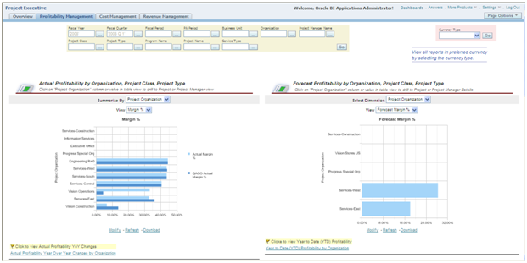

Actual Profitability by Organization, Project Class, Project Type allows you to report by Project Organization (show above), Project Class, Project Type or Program. You can View the information by Margin Percentage, Margin, Revenue, Cost and Data. Above, Actual Margin Percentage is compared to QAGO (one quarter prior) and Actual Margin. You can drill thru to Actual Profitability Year Over Year by Organization.

Forecast Profitability by Organization, Project Class, Project Type allows you to report by Project Organization (above), Project Type, Project Class, and Program Name. Forecast Margin Percentage by Project Organization is displayed above. You can drill thru to YTD Profitability by Organization.

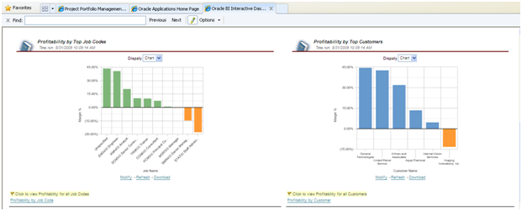

Profitability by Top Job Codes Displays (Chart or Table) Margin Percentages for all the Top Job Codes. You can click on the link to view Profitability for all Job Codes.

Profitability by Top Customers Displays (Chart or Table) Margin Percentages for the top customers. You can display Profitability for all Customers as well.

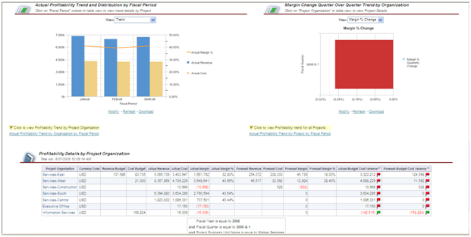

Actual Profitability Trend by Fiscal Period uses Views (Trend, Revenue Distribution, Cost Distribution, Margin Distribution and Data to report Actual Margin Percentage, Actual Revenue and Actual Cost. Margin Change Quarter Over Quarter Trend by Organization uses Views (Margin Percentage Change, Margin Change, and Data) to report quarterly margin changes.

Profitability Details by Project Organization Summarizes (Project Organization, Project Class, Project Type, or Program) Revenue Budget, Cost Budget, Actual Revenue, Actual Cost, Actual Margin, Actual Margin Percentage, Forecast Revenue, Forecast Cost, Forecast Margin, Actual/Cost Budget Variance, and Forecast/Budget Cost Variance.

**2.3 – Cost Management**

Provides the detailed cost information for the organizations and the projects under the organizations with the ability to drill down to projects, tasks and resources. It provides the cost comparisons of organizations, programs, expenditure categories, and cost variances by top projects, top resources, including trending with the ability to drill down to details.

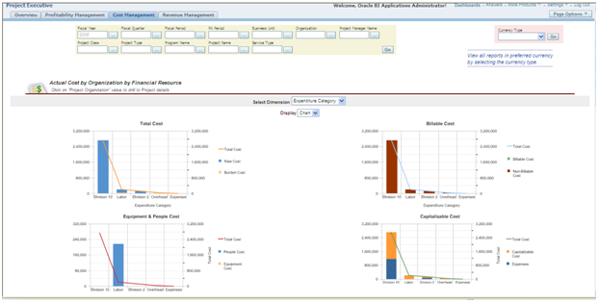

Actual Cost by Organization by Financial Resource uses Dimensions (Expenditure Category, Project Organinzation, Project Type, Program, and Supplier Name to Display (Chart or Table) Total Cost, Raw Cost, Burden Cost, People Cost, Equipment Cost, Billable Cost, Non-Billable Cost, Capitalizable Costs and Expenses. You can also drill thru to Actual Efforts by Organization by Financial Resource.

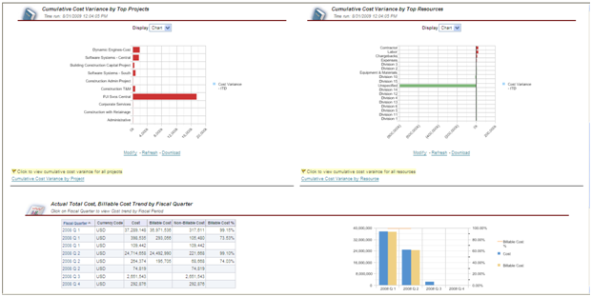

Cumulative Cost Variance by Top Projects Displays (Chart or Table) ITD cost variances for your top projects. You can view this information for all projects via Cumulative Cost Variance by Project. Cumulative Cost Variance by Top Resource displays variances for top resources. All resources may be viewed via Cumulative Cost Variance by Resource.

Actual Total Cost, Billable Cost Trend by Fiscal Quarter displays Cost, Billable Cost, Non-Billable Cost, and Billable Cost Percentage by quarter. You can click on the Fiscal Quarter to view Cost Trends. This information is displayed in tabular and graphical format.

You can drill thru to Cumulative Cost Billability by Project, Cumulative Cost Variance by Project, People Effort Trend by GL Period, Cumulative Cost Trend by Fiscal Period, and Cost Transactions.

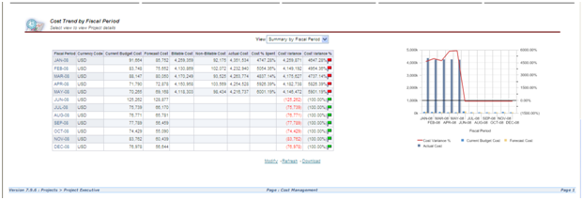

Cost Trend by Fiscal Period has two Views (Summary by Fiscal Period, Details by Project) of Current Cost Budget, Forecast Cost, Billable Cost, Non-Billable Cost, Actual Cost, Cost Percentage Spent, Cost Variance and Cost Variance Percentage. The information is display both in tabular and graphical format.

**2.4 – Revenue Management**

Provides the detailed Revenue, Billing and Funding information for the organizations and the projects under the organizations with the ability to drill down to projects, tasks and resources. It provides revenue, billing and funding comparisons of organizations, customers, and programs, and revenue performance by top projects, top customers including trending with the ability to drill down to details.

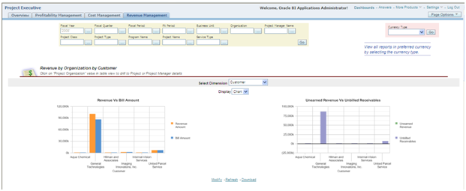

Revenue by Organization by Customer uses Dimensions (Customer, Revenue Category, Project Organization, and Program) to Display (Charts or Tables) to compare Revenue to Bill Amounts. In the table format, you can click on Project Organization to drill to Project or Project Manager details. Unearned Revenue vs Unbilled Receivables shows these amounts by the dimension selected.

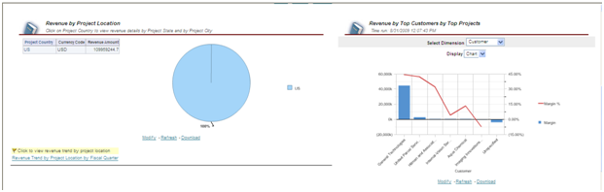

Revenue by Project Location initially displays the information by Country. You can click on the country to view revenue details by Project State and Project City. You can drill thru to Revenue Trend by Project Location by Fiscal Quarter.

Revenue by Top Customers by Top Projects allows you to select Dimensions (Customer or Project Name) to Display (Chart or Table) Margin and Margin Percentage by the dimension selected.

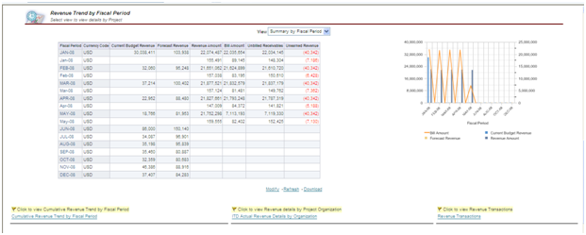

Revenue Trend by Fiscal Period allows you to choose a View (Summary by Fiscal Period or Details by Project) Current Budget Revenue, Forecast Revenue, Revenue Amount, Bill Amount, Unbilled Receivables, and Unearned Revenue. The information is displayed in table and graphical format. You can drill thru to Cumulative Revenue Trend by Fiscal Period, ITD Actual Revenue Details by Organization, and Revenue Transactions.

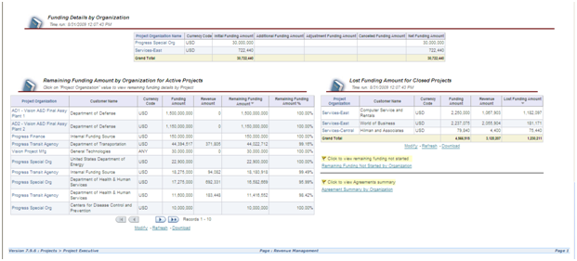

Funding Details by Organization displays Initial Funding Amount, Additional Funding Amount, Adjustment Funding Amount, Cancelled Funding Amount, and Net Funding amount by Project Organization. Remaining Funding Amount by Organization for Active Projects displays Project Organization, Customer, Funding Amount, Revenue Amount, Remaining Funding Amount, and Remaining Funding Amount Percentage in a table.

Lost Funding Amount for Closed Projects shows Project Organization, Customer, Funding Amount, Revenue Amount and Lost Funding Amounts. You can also drill thru to Remaining Funding Not Started by Organization or to Agreement Summary by Organization.

**Summary**

The Project Executive area of Project Analytics provides those users whose organizations are responsible for running projects the appropriate level of visibility into the type of information they need to effectively manage and forecast results for the enterprise. And since the pages are interactive, managers can focus on the metrics that are meaningful to the organization and download that information as needed.

[](http://www.projectp.com/)

Top of Form



Bottom of Form



* [Company](http://www.projectp.com/company/index.php)
  + [Overview](http://www.projectp.com/company/index.php)
  + [Executives](http://www.projectp.com/company/team.php)
  + [Alliances](http://www.projectp.com/company/alliances.php)
  + [News & Events](http://www.projectp.com/company/news.php)
* [Products](http://www.projectp.com/products/index.php)
  + [Overview](http://www.projectp.com/products/index.php)
  + [Invoicing](http://www.projectp.com/products/invoicing.php)
  + [OP3](http://www.projectp.com/products/op3.php)
  + [Const Contract Billing](http://www.projectp.com/products/cc_billing.php)
  + [Reporting](http://www.projectp.com/products/reporting.php)
  + [User Interface](http://www.projectp.com/products/ui.php)
  + [Product Support](http://support.projectp.com/)
* [Services](http://www.projectp.com/services/index.php)
  + [Overview](http://www.projectp.com/services/index.php)
  + [Oracle](http://www.projectp.com/services/oracle.php)
  + [Primavera](http://www.projectp.com/services/primavera.php)
  + [PMO](http://www.projectp.com/services/pmo.php)
* [Industries](http://www.projectp.com/industries/index.php)
  + [Overview](http://www.projectp.com/industries/index.php)
  + [Engineer / Construct](http://www.projectp.com/industries/engineering.php)
  + [Gov't Contracting](http://www.projectp.com/industries/government.php)
  + [Professional Svcs](http://www.projectp.com/industries/professional.php)
  + [Others](http://www.projectp.com/industries/others.php)
* [Customers](http://www.projectp.com/customers/index.php)
* [Resources](http://www.projectp.com/resources/index.php)
  + [Overview](http://www.projectp.com/resources/index.php)
  + [Webinars](http://www.projectp.com/resources/webinars.php)
  + [White Papers](http://www.projectp.com/resources/white.php)
  + [Presentations](http://www.projectp.com/resources/presentations.php)
  + [Q&A Forum](http://www.projectp.com/forum)
  + [Our Blog](http://www.projectp.com/weblog)
  + [Links](http://www.projectp.com/resources/links.php)
* [Product Demos](http://www.projectp.com/demos)
  + [Invoicing](http://www.projectp.com/demos/?product=invoicing)
  + [OP3](http://www.projectp.com/demos/?product=op3)
  + [Const Contract Billing](http://www.projectp.com/demos/?product=ccb)
  + [Presos & Whitepapers](http://www.projectp.com/demos/?product=oaug)
  + [User Interface](http://www.projectp.com/demos/?product=ui)
* [Promotions](http://www.projectp.com/promotions/index.php)
* [Contact Us](http://www.projectp.com/contact/index.php)
  + [Overview](http://www.projectp.com/contact/index.php)
  + [Careers](http://www.projectp.com/careers/index.php)
  + [Product Support](http://support.projectp.com/)

# Project Partners Blog

Browse: [Home](http://www.projectp.com/weblog) / [Services](http://www.projectp.com/weblog/category/services/) / Handling Resource Supply/Demand Using Project Resource Management

## Handling Resource Supply/Demand Using Project Resource Management

Posted on Mon 19 Oct 2009, 6:32 am, by John May, under [Services](http://www.projectp.com/weblog/category/services/).

## Challenges

Determine if you have a demand or supply oriented environment

* **Demand** resource management is more prevalent with internal resource organizations, i.e. IT organizations. The primary focus is to assure that resources are optimally allocated to projects in keeping with the organization’s stated goals and objectives. Or, in other words managing the problems of “everybody is over-booked” or “there’s more work than resources”.
* **Supply** resource management tends to be more attuned to billable professional resources. The primary focus is in balancing staff retention, skill mix and gross margins by assuring that resources are optimized to their maximum capacity. Or in other words “Is everybody billable?” or “Do we have enough analysts or too many designers?”
* **Professional services and other resource intensive organizations may have both issues at the same time**

## Solutions

### Identify/classify your resources

1. HR & PA Jobs
   1. “Billable” staff – know who are the resources you must schedule and track to assure success
      1. Billable staff are your most directly productive staff members and are critical to the success of a project. Plus they are generally the key indicator for forecasting project revenues
      2. Support Staff are important but generally are resources with less critical skill requirements and/or are in abundance and easy to fill
   2. Job Levels
      1. It is important to know who your senior resources are – whether senior is position, skill level or other management determination
      2. Generally denotes resource cost so Job levels help in optimizing performance and profitability/efficiency
2. Competencies
   1. Skill classification – Primary focus:
      1. Demand – Finding qualified people to do assignments who generally do ‘other’ work to balance workloads.
      2. Supply – Assuring that your resource mix is attenuated to your organization’s needs
   2. Grading
      1. Demand – Assuring that project assignments are optimized with the correct level of expertise to meet the prioritization of all projects.
      2. Supply – Assuring you have qualified resources to meet the client’s requirements

### Be able to classify your project requirements – Project Roles

1. Job Level – this will help to quickly narrow the field of potential candidates (see above)
2. Competencies – use mandatory competencies sparingly. Using optional competencies helps in prioritizing identified candidates.
3. Role Groups
   1. If you have a diverse workforce and require many Project Roles, create more Role Groups to minimize the list of Project Roles an individual project manager must deal with.
   2. Roles also help focus standardization of project requirements by eliminating ‘ad hoc’ project roles.

## Matching Resources and Requirements

Automated Processing – Most important processes to make sure you are getting the correct resource data on a timely basis:

* PRC: Automated Candidate Search for a Range of Projects
* PA: HR Related Updates Workflow

## Getting Started

### General Suggestions

* Most small to mid-sized organizations know their resources by name – so placing them is pretty straight-forward using direct assignments
* These organizations aren’t searching for ‘hidden’ talents – so complex competency searches are irrelevant
* Mid- to large sized organizations rely more on job levels and or competencies when identifying candidates for project requirements.

### Demand Environment Suggestions

* Avoid micro-managing resource assignments
  + Effort involved in maintaining daily changes to forecasts is generally not time efficient
  + Forecasting will never be perfect – allow your variances to help determine what magnitude of changes are most important to track
* Establish minimum requirement guidelines – examples:
  + Try using a 20% rule: Only schedule resources to an assignment if it is equal to or greater than 8 hours per week
  + Ignore forecasting small assignments of less than 25% of time of a resource’s weekly capacity.

### Supply Environment

* Be sure to track your variance reports of forecasted to actual hours
* Review your over-commitment reports
  + Overcommitments can cause bottlenecks on project schedules;,
  + Bottlenecks lead to missed deadlines or put pressures on project margins

## Reporting

Oracle currently provides Discoverer workbooks and Project Intelligence (PJI) reporting. Review what is available before you design you own reports. While Oracle reporting out of the box is not always suitable, it can give you a great starting point to developing and/or conforming to your own reporting infrastructure.

Note:    If you are licensed to use Project Resource Management, then you are licensed to use the PJI Resource Reporting.

### DISCO Workbooks – Staffing

* Scheduled Resource Hours
  + Simple: Capacity, Total, Provisional hours
  + Three periods
* Available Resource Hours
* Overcommitted Resource Hours
* Team Role Details
* Required Project Hours

### DISCO Workbooks – Resources

* Organization Competence Summary
* Resource Competencies

### PJI Utilization Reports

* Projects Resource Utilization and Availability
* Projects Utilization Summary
* Projects Utilization Trend
* Projects Actual Utilization
* Projects Scheduled Utilization
* Projects Expected Utilization
* Projects Actual Utilization Detail
* Projects Scheduled Utilization Detail
* Projects Expected Utilization Detail

### PJI Projects Resource Availability Reports

* Projects Available Time Summary
* Projects Availability Trend
* Projects Current Available Resources
* Projects Available Resources Duration

[](http://www.projectp.com/)

Top of Form



Bottom of Form



* [Company](http://www.projectp.com/company/index.php)
  + [Overview](http://www.projectp.com/company/index.php)
  + [Executives](http://www.projectp.com/company/team.php)
  + [Alliances](http://www.projectp.com/company/alliances.php)
  + [News & Events](http://www.projectp.com/company/news.php)
* [Products](http://www.projectp.com/products/index.php)
  + [Overview](http://www.projectp.com/products/index.php)
  + [Invoicing](http://www.projectp.com/products/invoicing.php)
  + [OP3](http://www.projectp.com/products/op3.php)
  + [Const Contract Billing](http://www.projectp.com/products/cc_billing.php)
  + [Reporting](http://www.projectp.com/products/reporting.php)
  + [User Interface](http://www.projectp.com/products/ui.php)
  + [Product Support](http://support.projectp.com/)
* [Services](http://www.projectp.com/services/index.php)
  + [Overview](http://www.projectp.com/services/index.php)
  + [Oracle](http://www.projectp.com/services/oracle.php)
  + [Primavera](http://www.projectp.com/services/primavera.php)
  + [PMO](http://www.projectp.com/services/pmo.php)
* [Industries](http://www.projectp.com/industries/index.php)
  + [Overview](http://www.projectp.com/industries/index.php)
  + [Engineer / Construct](http://www.projectp.com/industries/engineering.php)
  + [Gov't Contracting](http://www.projectp.com/industries/government.php)
  + [Professional Svcs](http://www.projectp.com/industries/professional.php)
  + [Others](http://www.projectp.com/industries/others.php)
* [Customers](http://www.projectp.com/customers/index.php)
* [Resources](http://www.projectp.com/resources/index.php)
  + [Overview](http://www.projectp.com/resources/index.php)
  + [Webinars](http://www.projectp.com/resources/webinars.php)
  + [White Papers](http://www.projectp.com/resources/white.php)
  + [Presentations](http://www.projectp.com/resources/presentations.php)
  + [Q&A Forum](http://www.projectp.com/forum)
  + [Our Blog](http://www.projectp.com/weblog)
  + [Links](http://www.projectp.com/resources/links.php)
* [Product Demos](http://www.projectp.com/demos)
  + [Invoicing](http://www.projectp.com/demos/?product=invoicing)
  + [OP3](http://www.projectp.com/demos/?product=op3)
  + [Const Contract Billing](http://www.projectp.com/demos/?product=ccb)
  + [Presos & Whitepapers](http://www.projectp.com/demos/?product=oaug)
  + [User Interface](http://www.projectp.com/demos/?product=ui)
* [Promotions](http://www.projectp.com/promotions/index.php)
* [Contact Us](http://www.projectp.com/contact/index.php)
  + [Overview](http://www.projectp.com/contact/index.php)
  + [Careers](http://www.projectp.com/careers/index.php)
  + [Product Support](http://support.projectp.com/)

# Project Partners Blog

Browse: [Home](http://www.projectp.com/weblog) / [Products](http://www.projectp.com/weblog/category/products/) / Project Status Reporting via Microsoft® Excel

## Project Status Reporting via Microsoft® Excel

Posted on Fri 5 Feb 2010, 2:16 pm, by Kimberly Baker, under [Products](http://www.projectp.com/weblog/category/products/).

By Peter Budelov

Project Managers (PMs) lead a hectic life because they not only need to manage the day-to-day operations of a project (i.e. work deliverables, schedules, cost and revenue), but they also must spend time with the appropriate IT tools to do this.  The keystone in making good project management decisions is having accurate, timely and easy to access project reporting data.

Typically when using enterprise project management applications, this data is available, but not necessarily easy to get to, may not be easily displayed in a user friendly manner, does not necessarily have all the data needed, is not configurable, and certainly unavailable in a disconnected mode.

Project Partners User Interface Applications™ utilize Microsoft® Excel spreadsheets as the interface with Oracle E-Business Suite applications, showing just what Project Managers want to see, the way they prefer to see it.  Project Partners Reporting™ leverages the technology of our User Interface Applications (UI-Apps) to provide Project Status Reporting for Project Managers.

In Project Partners Reporting, a proprietary summarization process makes key project reporting data available to Project Managers with added dimensions of configurability.  The result is not only reporting of dry factual data, e.g. cost, revenue, margin or margin percent, but additionally, the UI-Apps workbook has built-in logic to display configurable indicators that dynamically present different indicators based upon thresholds for each reported metric in every worksheet.  These indicators can be color coded (e.g. red, yellow, or green) to indicate if a metric in trouble, at risk, or OK based upon the defined threshold.

To use the UI-Apps Reporting Workbook, users first search for projects (using various selection criteria) and select the projects they want to review; up to 20 projects may be selected at one time – summarized reporting data for all will be downloaded into the workbook.  At this point, the user may work offline if desired – something essential to PMs for whom travel is part of the job. The projects will be displayed in a list and based upon a few high-level project-health indicators that are shown for each, the user may drill down to the specifics for a single project.

The Project Metrics Worksheet displays a graphical representation of the project’s status (Earned Value, Cost, Revenue, and Schedule overview).

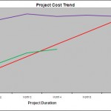

Project Metrics: Project Cost Graph

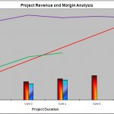

Project Metrics: Revenue Margin Graph

A hyperlink takes the user to the next worksheet in the workbook, Project Summary, which displays overall project setup values and dates, key performance indicators with metrics and KPI indicators, plus aged bill and payment amounts and a summary of cost and revenue by period broken down by type of cost, revenue and margin.

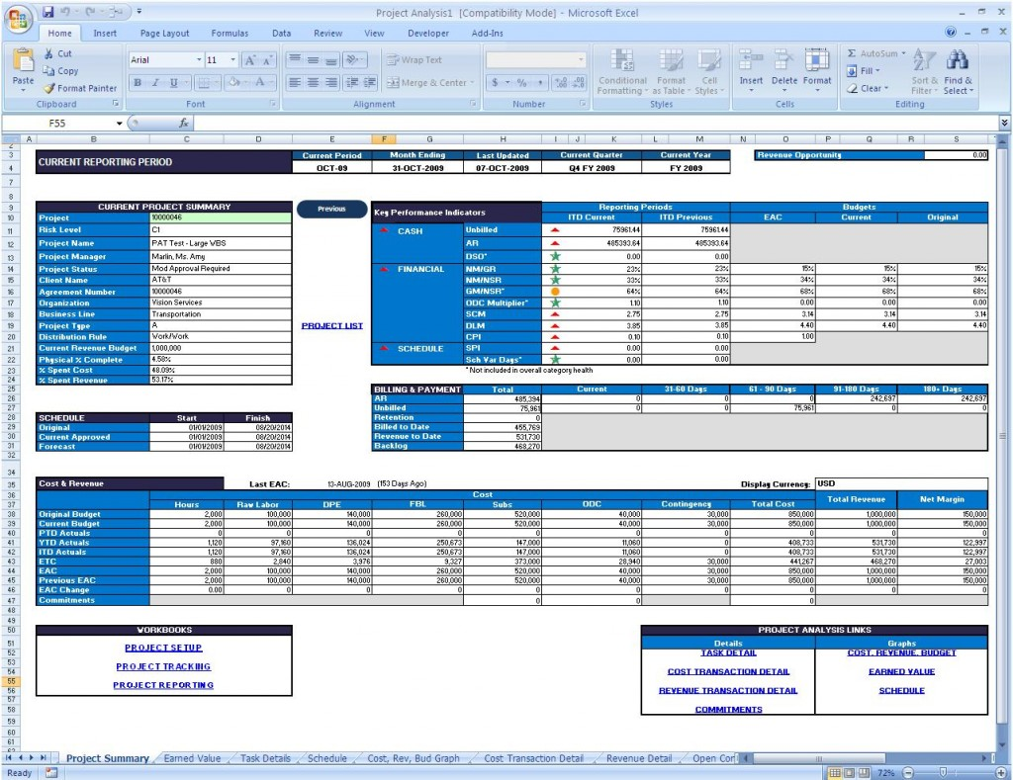

Project Summary Worksheet

The Project Schedule worksheet displays each task of the WBS with task date information and an optionally displayed Gantt chart showing task start/end date, duration and percent complete.

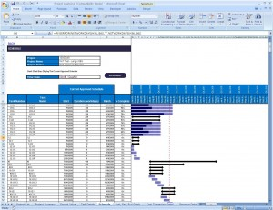

Projecct Schedule Worksheet

The Task Details Sheet has a sophisticated real-time configurable display to show desired details by-task of budget, forecast, actual (cost and revenue, committed and earned value amounts broken down by type of cost, period incurred as appropriate.

These metrics allow project managers to easily and quickly see (a) the overall health of their projects, (b) the WBS and schedule details, (c) the financial and schedule metrics by task, and finally drilldown to the transaction detail to research cost, revenue and committed amounts.

The Net/Net

For Project Managers who want to use the familiarity of Microsoft® Excel to manage their projects, UI-Apps gives them just what they need, and nothing more. For Project Managers who need to be able to work in a disconnected fashion while on the road, UI-Apps also enables them to be more productive by utilizing downtime that previously was relegated to travel.

You’ll find more information here: <http://www.projectp.com/products/reporting.php>